ITEM#:50059
PARTS LIST：
A | Table Top | 1pc | B | Table Body | 1pc
C | Table Base | 1pc

**Please make sure you have all the parts indicated above before you begin assembly of this item. This item should be assembled on a soft surface to prevent scratching the finish during assembly.

1. Carefully place all parts on a soft surface.
2. Put the plastic washer around the threaded pipe in the table base (C), rotate the table body (B) into the table base (C).
3. Rotate the table top (A) into the table body (B).
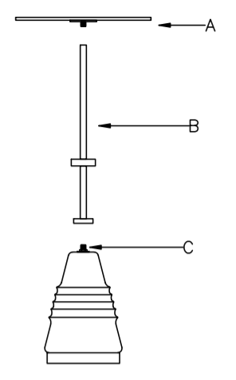
Assembly is now complete.

