ITEM#:30352
PARTS LIST：
- Finial B. Shade C. Harp D. Bulb(Not Included) E. Harp Base F. Ceramic Part G. Top Metal Post H. Metal Post I. Base
**Please make sure you have all the parts indicated above before you begin assembly of this item. This item should be assembled on a soft surface to prevent scratching the finish during assembly. This item may require periodic tightening.
1. Place the base in a right position on the floor.  2. Pull the cord & make sure it does not get damaged.  3. Ensure the Metal Post(H) is aligned with Base (I), then spin the Metal Post(H) into the Base (I) to tighten. Next take Ceramic Part (F) and spin into the Top Metal Post(G)to tighten.  4. Put the harp(C) into the harp base (E), and then put the shade (B) onto the harp(C).  5. Put the finial (A) onto the harp and turn clockwise to tighten securely.  6. Use a 3-way 150W bulb(D) (not included).  IMPORTANT SAFETY INSTRUCTIONS | 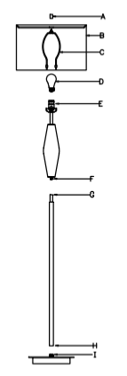

This portable lamp has a polarized plug (one Blade is wider than the other) as a safety feature to reduce the risk of electric shock. This plug will fit in a polarized outlet. Reverse the plug, if it still does not fit, contact a qualified electrician. Never use with an extension cord unless plug can be fully inserted. Do not attempt to defeat this safety feature.

