UTTERMOST
ASSEMBLY INSTRUCTIONS
STYLE NO: 22997
CAREFULLY UNPACK ALL PARTS FROM THE CARTON
1. Please place table base (B) on a smooth surface carefully.
2. Please place table top (A) on the table base properly and rotate 90 degrees.
To clean, wipe with soft dry cloth.

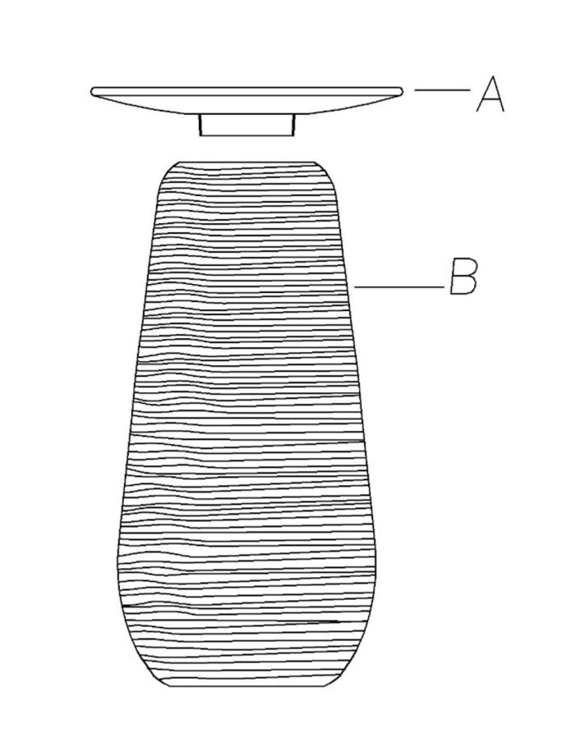

P. O. Box 558 | 3325 Grassy Hill Road |Rocky Mount, VA | 24151
www.uttermost.com

